Noun Clause

✅ Definition:
# Source: Chatgpt (GPT-4-turbo) at [7/29/2025]
A noun clause is a dependent clause that acts as a noun in a sentence.
It can function as a subject, object, or complement in a sentence.
It often begins with that, what, who, why, if, how, or other wh-words.

🧩 Structure:
# Source: Chatgpt (GPT-4-turbo) at [7/29/2025]
[Introductory word] + subject + verb
Examples:
- What she said was important.
- I know that he is honest.
- They wondered why she left.

🎯 Functions of Noun Clauses:
# Source: Chatgpt (GPT-4-turbo) at [7/29/2025]
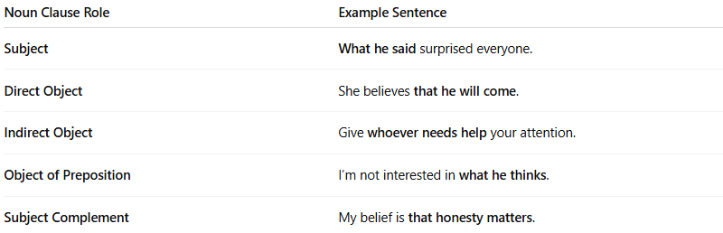
Noun Clause Role | Example Sentence
Subject | What he said surprised everyone.
Direct Object | She believes that he will come.
Indirect Object | Give whoever needs help your attention.
Object of Preposition | I’m not interested in what he thinks.
Subject Complement | My belief is that honesty matters.

🔍 Common Introducers of Noun Clauses:
# Source: Chatgpt (GPT-4-turbo) at [7/29/2025]
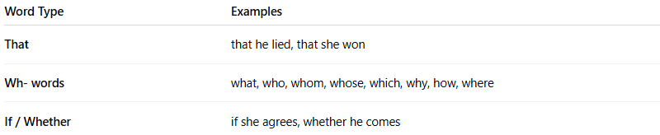
Word Type | Examples
That | that he lied, that she won
Wh- words | what, who, whom, whose, which, why, how, where
If / Whether | if she agrees, whether he comes

✏️ Example Breakdown:
# Source: Chatgpt (GPT-4-turbo) at [7/29/2025]
- I believe that she is right.
→ "that she is right" = noun clause as object
- What you said is true.
→ "What you said" = noun clause as subject
- The fact is that we were wrong.
→ "that we were wrong" = noun clause as complement

🚫 Tips:
# Source: Chatgpt (GPT-4-turbo) at [7/29/2025]
- A noun clause cannot stand alone.
- If you can replace the clause with "it" or "something", it’s likely a noun clause:
I know that he lied. → I know something. ✅

🧠 Quick Practice: Identify the noun clause
# Source: Chatgpt (GPT-4-turbo) at [7/29/2025]
- She doesn’t know what he wants.
- That you passed the exam is wonderful.
- Tell me how you did that.
Answers:
- what he wants → object
- That you passed the exam → subject
- how you did that → direct object

